

AGGREGATE FUNCTIONS

WAQAS ASHIQ.

BCS-F11-201.

SECTION C.

SUBMITTED TO: Sir.Hafiz Rizwan

student :

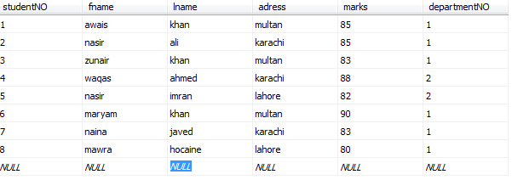

department :

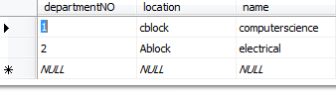

Querry # 1 :

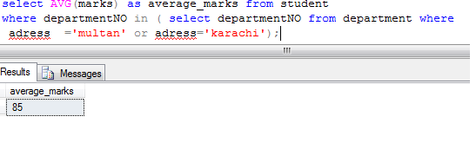

Querry#2:

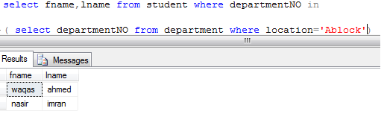

Querry#3:

